Contact Details
 |  |  | Date :
Parents Name:
Contact Phone: |  |  | Email:
Childs Name: |  |  | Class:

Payment
 | Order Total | $

Payment Method: |  | Credit Card | Cash | Cheque
 |  | Cheques payable to WHPS Clothing Pool
Name on Card: |  |  |  |  | Visa Master Card
Card Number: | / / / |  |  | Expiry Date : |  | /
CVV No. _______

Delivery
 | Leave at Front Office  Already Taken | Send home with my child

Packed | Advised | Delivered | Order Number

Wanniassa Hills Primary School
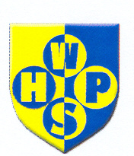

School Uniforms
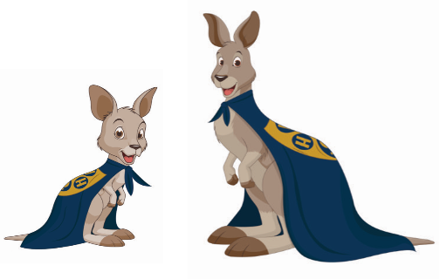
Online Ordering System – www.quickcliq.com.au

Open 8:45 am – 9:30 am First Wednesday of each month
Contact: Elesa Kurtz – 0410 503 258
Email: whps.uniforms@gmail.com

Item | Price | Sizes | Colour | Qty | Size | Total
Shirts
Polo – Short Sleeve | $20 | 4 6 8 10 12 14 16 | Gold with logo
Polo – Long Sleeve | $20 | 4 6 8 10 12 14 16 | Gold with logo
Polo – Short Sleeve | $23 | 4 6 8 10 12 14 16 | Royal Blue with logo
Polo – Long sleeve | $20 | 4 6 8 10 12 14 16 | Royal Blue with logo
Polo – Short Sleeve | $26 | Med | Royal Blue with logo
Shorts Skirts etc
Mesh Shorts Unisex | $12 | 4 6 8 10 12 14 16 | Royal Blue
Skorts | $18 | 4 6 8 10 12 14 | Royal Blue
Sports Skirt | $18 | 6 8 10 12 14 16 | Royal Blue
Boys Gaberdine  Shorts | $15 | 4 6 8 10 12 14 16 | Royal Blue
Pants
Track Suit Pants – Fleecy-double knee  With cuff | $22 | 4 6 8 10 12 14 16 | Royal Blue
Tracksuit – Fleecy-double knee (straight leg) | $22 | 4 6 8 10 12 14 16 | Royal Blue
Tracksuit – Microfibre Zip Cuffs | $26 | 4 6 8 10 12 14 16 | Royal Blue
Tracksuit – Microfibre Straight leg | $26 | 4 6 8 10 12 14 16 | Royal Blue
Leggings | $12 | 4, 6, 8, 10, 12, 14, 16 | Navy
 |  |  |  | Sub Total $

We also stock a range of second-hand clothing at low prices
Item | Price | Sizes | Colour |  | Qty | Size | Total
Dresses
Summer Polo Dress | $30 | 4,6,8,10,12,14  16 | Royal Blue & Gold
Jackets & Jumpers
Flying Jacket | $34 | 4 6 8 10 12 14 16 | Royal Blue
Polar Fleece Full Zip | $28 | 4 6 8 10 12 14 16 | Royal Blue
Polar Fleece Half Zip | $27 | 6 8 10 12 14 16 | Royal Blue
Polar Fleece Vest | $22 | 4 6 8 10 12 14 16 | Royal Blue
Sweatshirt – Fleecy | $22 | 4 6 8 10 12 14 16 | Royal Blue
Junior Hoodie | $29 | 4 6 8 10 | Royal Blue
Senior Hoodie  (Years 3-6 only) | $29 | 8 10 12 14 16 Small Adult | Royal Blue
Other
Bucket Hat | $10 | Small Medium Large | Royal Blue
Microfibre Hat | $10 | S/M M/L L/XL | Royal Blue
Polar Fleece Beanie | $5 | One Size | Royal Blue
School Bag | $45 | Large only | Blue
Library Bag | $8 | One size | Blue
House Hat | $10 | One size | Pemberton Blue
House Hat | $10 | One size | Beatty Green
House Hat | $10 | One size | Rob Roy Yellow
House Hat | $10 | One size | Simpson Red
 |  |  |  |  | Order Total $

