Wanniassa Hills Primary School

School Uniforms
Term 1 2018
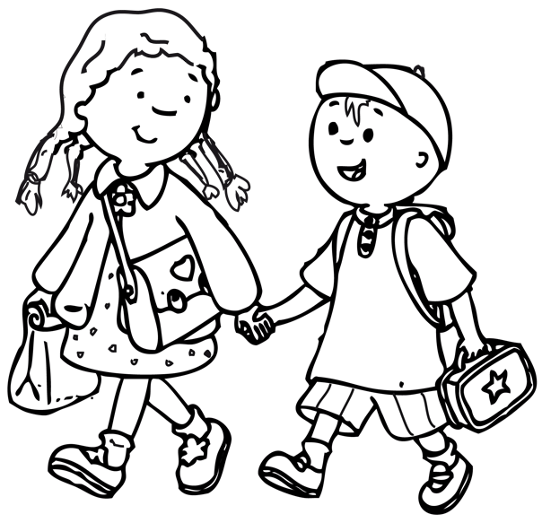

Online Ordering System – www.ouronlinecanteen.com.au

Open 8:45 am – 9:30 am First Thursday of each month
Contact: Karen Carmody – 0466 982 904
Email: whps.uniforms@gmail.com
Item | Price | Sizes | Colour | Qty | Size | Total
Shirts
Polo – Short Sleeve | $20 | 4 6 8 10 12 14 16 | Gold with logo
Polo – Long Sleeve | $20 | 4 6 8 10 12 14 16 | Gold with logo
Polo – Short Sleeve | $23 | 4 6 8 10 12 14 16 | Royal Blue with logo
Shorts Skirts etc
Mesh Shorts Unisex | $10 | 6 8 10 12 14 16 | Royal Blue
Skorts | $16 | 4 6 8 10 | Royal Blue
Sports Skirt | $16 | 6 8 10 12 14 16 | Royal Blue
Boys Gaberdine  Shorts | $14 | 4 6 8 10 12 14 16 | Royal Blue or Grey
Pants
Track Suit Pants – Fleecy-double knee | $20 | 6 8 10 12 14 16 | Royal Blue
Tracksuit – Microfibre Zip Cuffs | $22 | 6 8 10 12 14 16 | Royal Blue
Tracksuit – Microfibre Straight leg | $22 | 6 8 10 12 14 16 | Royal Blue
Girls ponte pants | $23 | 8, 10, 12, 14, 16 | Royal Blue
 |  |  |  | Sub Total $

We also stock a range of second hand clothing at low prices

Item | Price | Sizes | Colour |  | Qty | Size | Total
Dresses
School Dress | $40 | 4,5,6, 8,10, 12, 14, 16 | Blue, Gold & White check
Winter Tunic | $45 | 4,5,6,7,8,10, 12, 14 | Royal Blue
Jackets & Jumpers
Flying Jacket | $33 | 4 6 8 10 12 14 16 | Royal Blue
Polar Fleece Full Zip | $25 | 4 6 8 10 12 14 16 | Royal Blue
Polar Fleece Half Zip | $23 | 6 8 10 12 14 16 | Royal Blue
Polar Fleece Vest | $17 | 4 6 8 10 12 14 16 | Royal Blue
Year 6 Rugby Top | $65 | 12, 14, 16, S, M, L
Sweat Shirt - Fleecy | $18 | 4 6 8 10 12 14 16 | Royal Blue
Other
Bucket Hat | $10 | Small Medium Large | Royal Blue
Slouch Hat | $10 | Small Medium Large | Royal Blue
Polar Fleece Beanie | $5 | One Size | Royal Blue
School Bag | $32 /  $34 | Medium or Large | Blue
Library Bag | $5 |  | Various
Cloth Badge | $3.50 |  | Blue Gold
 |  |  |  |  | Order Total $

Contact Details
 |  |  | Date :
Parents Name:
Contact Phone: |  |  | Email:
Childs Name: |  |  | Class:

Payment
 | Order Total | $

Payment Method: |  | Credit Card | Cash | Cheque
 |  | Cheques payable to WHPS Clothing Pool
Name on Card: |  |  |  |  | Visa Master Card
Card Number: | / / / |  |  | Expiry Date : |  | /
CVV No. _______

Delivery
 | Leave at Front Office | Send home with my child

Packed | Advised | Delivered | Order Number

G:\Doco\Admin\whps\Information Folder Forms\Clothing Pool\Clothing Pool Price List 2011.docx

